 TRANSIENT STABILITY ANALYSIS

Transient stability analysis enables engineers to accurately model power system dynamics and transients by simulating system disturbances and other events.

Typical transient stability studies include identifying critical fault clearing time, checking generator rotor angle stability, assessing system stability margin, evaluating motor dynamic acceleration and re-acceleration impact, preparing and testing load shedding schedule, computing fast bus transfer timing, calibrating and evaluating relay setting and simulating generator start-up. You can split a system or combine multiple subsystems, simulate automatic relay actions and associated circuit breaker operations, and start or auto-start motors. Combined with enhanced plotting and graphical results, engineers can truly use transient stability analysis program to master power system stability studies.

1. Key Features:
   1. Complete synchronous & induction machine models
   2. Integrated with User-Defined Dynamic Models (UDM) Program
   3. Short-time & long-time transient simulations
   4. Variable total simulation time & simulation step
   5. Frequency dependent modeling for synchronous machines (sub-transient models) and induction machines
2. Transient Stability Software Capabilities
   1. Simulate Generator Start-Up (optional feature)
   2. Set & adjust exciter, AVR, turbine or engine parameters
   3. Set speed governor parameters
   4. Set & adjust control relays
   5. Simulate loss of excitation
   6. Induction and synchronous motor acceleration
   7. MOV starting
   8. Relay-controlled actions
   9. Automatic load shedding
   10. User-controlled simulation parameters
   11. Handle multiple subsystems and islanding systems
   12. Power system static VAR Compensator (SVC) model
   13. High voltage direct current transmission (HVDC) model
   14. Calculate Critical Fault Clearing Time (CFCT)
   15. Calculate Critical Separation Time (CST)
   16. Fast load transferring
   17. Load Shedding
   18. Rotor Angle Responses

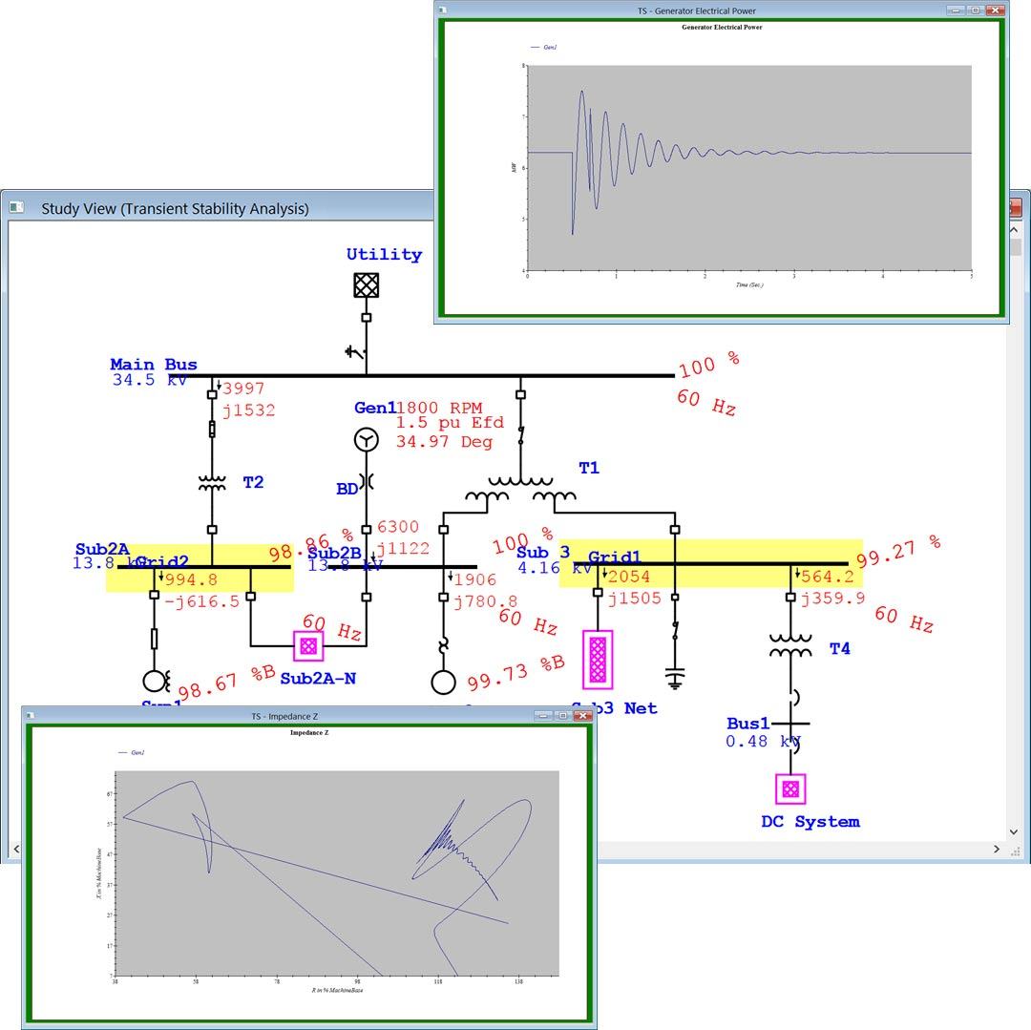

Figure : Transient stability analysis on a system